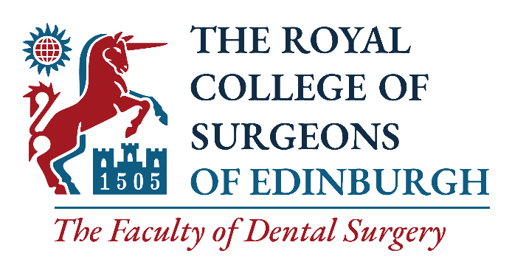

Candidate Information Form for Elected Members
of Dental Council
________________________________________________________

Please complete this form and return to dental@rcsed.ac.uk by 09:00 on Wednesday 12 May 2021.

Full name
TITLE
college reference no.
To find your College Reference Number, please go to www.rcsed.ac.uk and log into your account. You will find your Reference Number on the My Profile.
DATE OF ELECTION to FELLOWship
Home address

WORK ADDRESS

MOBILE
EMAIL
title of current post

specialty including sub-specialty interest

KEY MANAGEMENT ROLES

committee work

training and education roles

research and clinical work

key areas of interest IN SUPPORTING PROFESSIONAL ACTIVITIES

contributions to the dental faculty/rcsed: Examiner, committees, AMBASSADOR, etc.
Please complete the following, in no more than 150 words.

Please outline your aspirations for the future regarding involvement with the Dental Faculty / RCSEd.

I attach a letter of support from my main employer. YES / NO
PROBITY DECLARATION

I declare that I have not, in the UK or outside:
- Been convicted of a criminal offence (including any spent convictions) or have proceedings pending against me.
- Been subject to disciplinary proceedings, reprimand or suspension by the General Dental Council in the United Kingdom or any equivalent Regulatory or Licensing Body elsewhere.
- Been erased from the Register of the relevant registering body or failed to comply with conditions or qualifications imposed by the relevant registering body under performance review procedures.
- Had any disciplinary actions taken against me by an employer or contractor or have had any contract terminated or suspended on grounds relating to my fitness to practice.

CONSENT

I consent to this nomination.

SIGNATURE

Signature:

Date:

Please e-mail your completed candidate information form, a signed nomination form and a letter of support from your main employer to dental@rcsed.ac.uk by 09.00 on Wednesday 12 May 2021.

Further information:
If you have any queries, please contact the Faculty of Dental Surgery at dental@rcsed.ac.uk

By submitting this application, you understand that RCSEd will process your personal data in accordance with the terms of the General Data Protection Regulation (GDPR).

For the purposes of this election any personal data you provide will be shared with the RCSEd Fellows and Members in Dental Surgery to enable voting and with Civica Election Services (CES). You can read their Privacy, Security and Copyright Statement at https://secure.cesvotes.com/V3-1-0/rcsed2021/en/policystatement

We will not share your data with any third party unless there is a statutory requirement for us to do so or unless we require to do so to deliver our services. Such sharing will only be undertaken where the appropriate Data Processing Agreements are in place and for tightly controlled purposes. The College will retain your data for the periods of time described in our privacy statement. Further details may be found on our website at https://www.rcsed.ac.uk/privacy.

