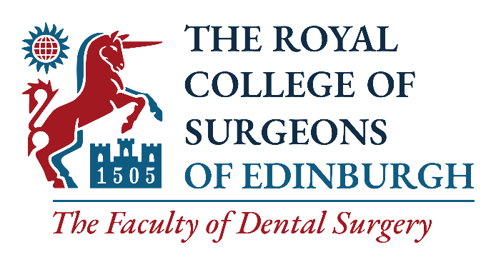

Nomination Form for Elected Members of Dental Council
________________________________________________________

We, the undersigned Fellows in Dental Surgery of the Royal College of Surgeons of Edinburgh nominate
for the office of Member of Dental Council, their consent to this nomination having been obtained:

PROPOSER
FULL NAME
college reference no. | To find your College Reference Number, please go to www.rcsed.ac.uk and log into your account. You will find your Reference Number on the My Profile tab.
EMAIL
SIGNATURE |  | DATE

SECONDER
FULL NAME
college reference no. | To find your College Reference Number, please go to www.rcsed.ac.uk and log into your account. You will find your Reference Number on the My Profile tab.
EMAIL
SIGNATURE |  | DATE

Please complete this form and return to dental@rcsed.ac.uk by 09:00 on Wednesday 12 May 2021.

For further information, please contact the Faculty of Dental Surgery at dental@rcsed.ac.uk

By submitting this application, you understand that RCSEd will process your personal data in accordance with the terms of the General Data Protection Regulation (GDPR).

For the purposes of this election your name will be shared with Civica Election Services (CES). You can read their Privacy, Security and Copyright Statement at https://secure.cesvotes.com/V3-1-0/rcsed2021/en/policystatement

We will not share your data with any other third party unless there is a statutory requirement for us to do so or unless we require to do so to deliver our services. Such sharing will only be undertaken where the appropriate Data Processing Agreements are in place and for tightly controlled purposes. The College will retain your data for the periods of time described in our privacy statement. Further details may be found on our website at https://www.rcsed.ac.uk/privacy.

